Intern Detail

|  |  |
| --- | --- |
| Field | **Details** |
| Name | Simran Gupta |
| College Name | United College of Engineering and Research |
| Branch | B.Tech – Computer Science |
| Roll Number | 2200100100344 |
| Internship  Provider | SmartInternz |
| Internship  Domain | Data Analytics using Power BI |
| Project Title | Visualizing the Future of Farming: A Power BI Project  on Smart Irrigation and Plant Growth |
| Project Type | Group Project (Self-led) |
| Project  Description | Predicting plant growth stages using environmental  and management data with Power BI dashboards |

**Final Project on**

**Visualizing the Future of Farming: A Power BI Project on Smart Irrigation and Plant Growth**

* Introduction
  + Project overviews
  + Objectives
* Project Initialization and Planning Phase
  + Deﬁne Problem Statement
  + Initial Project Planning
  + Project Proposal (Proposed Solution)
* Data Collection and Preprocessing Phase
  + Data Exploration and Preprocessing
  + Data Quality Report
  + Data Collection Plan and Raw Data Sources Identiﬁed
* Data Visualization
  + Framing Business Questions
  + Developing Visualizations
* Dashboard
  + Dashboard Design File
* Report
  + Story Design File
* Performance Testing
  + 7.1 Utilization of Data ﬁlters
  + 7.2 No of Calculation Field
  + 7.3 No of Visualization
* Conclusion/Observation
* Future Scope
* Appendix
  + Source Code
  + GitHub & Project Demo Link

**Introduction**

**Visualizing the Future of Farming: *A Power BI Project on Smart Irrigation and Plant Growth:***

**Project Overview**

Agriculture is facing mounting pressure to feed a growing global population while minimizing

environmental impact. With water scarcity and climate variability becoming more prominent challenges, the adoption of smart irrigation and precision farming is no longer optional—it’s essential.

This project titled **"Visualizing the Future of Farming"** leverages Power BI to analyze and visualize agricultural data with a focus on **smart irrigation** and **plant growth optimization**. Using publicly available datasets and advanced data visualization techniques, the project provides actionable insights to help farmers, researchers, and policymakers make data-driven decisions.

The interactive dashboards created showcase how data filtering, calculated fields, and key visualizations can highlight performance variations in different soil types (e.g., clay, loam, sand) and the impact of irrigation strategies on crop yield and plant health.

**Objectives**

* To analyse plant growth data across multiple soil types using Power BI.
* To build interactive and dynamic dashboards that support smart irrigation decisions.
* To provide insights on resource optimization like water usage and soil performance.
* To demonstrate real-world use of Business Intelligence tools in agriculture.
* To encourage the use of data-driven techniques for sustainable farming practices.

**Project Initialization and Planning Phase**

|  |  |
| --- | --- |
| Date | 04-08-2025 |
| Team ID | Simran Gupta |
| Project Name | Visualizing the Future of Farming: |
| Maximum Marks | 3 Marks |

**Problem Statements :**

The Customer Problem Statement helps you focus on what matters to create experiences people will love. A well-articulated customer problem statement allows you and your team to find the ideal solution for your customers' challenges. Throughout the process, you’ll also be able to empathize with your customers, which helps you better understand how they perceive your product or service.

|  |  |  |  |  |  |
| --- | --- | --- | --- | --- | --- |
| Problem  Statement (PS) | I am (Customer) | I’m trying to | But | Because | Which makes me feel |
| PS-1 | A small- scale farmer | Improve crop yield using smart irrigation | I don't have access to data- driven insights | Traditional methods don’t tell me when and how much  to irrigate | Frustrated and unsure about making the right farming  decisions |
| PS-2 | An agricultural officer | Track the efficiency of irrigation systems in different  regions | Data from farms is unorganized and hard to interpret | There's no centralized tool that visualizes performance in real-time | Inefficient in decision-making and overwhelmed |
| PS-3 | A farm equipment distributor | Understand what kind of irrigation solutions are most needed | I don’t know what challenges farmers face with irrigation  or crop growth | I lack real-time, location-based insights | Uncertain about customer needs and how to market effectively |
| PS-4 | An agri-tech consultant | Recommend sustainable farming  practices | I don’t have visual data to support my  analysis | My clients can’t understand raw data without  visuals | Less convincing, and my advice feels less  credible |

**Initial Project Planning**

|  |  |
| --- | --- |
| Date | 04-08-2025 |
| Team ID | Simran Gupta |
| Project Name | Visualizing the Future of Farming:  A Power BI Project on Smart Irrigation and Plant Growth |
| Maximum Marks | 4 Marks |

**Product Backlog, Sprint Schedule, and Estimation**

|  |  |  |  |  |  |  |  |  |
| --- | --- | --- | --- | --- | --- | --- | --- | --- |
| **Sprint** | **Functional Requirement (Epic)** | **User Story Numbe**  **r** | **User Story / Task** | **Story Point s** | **Priority** | **Team Member s** | **Sprin t Start**  **Date** | **Sprint End Date (Planned**  **)** |
| **Sprint**  **-1** | Data Collection & Preparation | USN-1 | As a user, I want the data to be collected from reliable agricultural sources so that it reflects realistic  conditions. | 3 | High | Self | 21-  07-  2025 | 21-07-  2025 |
| **Sprint**  **-1** | Data Cleaning | USN-2 | As a user, I want missing and duplicate data to be cleaned, ensuring that the dataset is  accurate. | 2 | High | Self | 22-  07-  2025 | 23-07-  2025 |
| **Sprint**  **-2** | Data Modelling | USN-3 | As a user, I want relationships between data tables to be clearly defined, so I can analyse them in Power  BI. | 3 | Mediu m | Self | 24-  07-  2025 | 24-07-  2025 |

|  |  |  |  |  |  |  |  |  |
| --- | --- | --- | --- | --- | --- | --- | --- | --- |
| **Sprint**  **-2** | Dashboard Design | USN-4 | As a user, I want to view plant growth performance by soil type, fertilizer, and irrigation via an interactive  dashboard. | 4 | High | Self | 24-  07-  2025 | 27-07-  2025 |
| **Sprint**  **-3** | Smart Insights & Recommendation s | USN-5 | As a user, I want the system to recommend best growth conditions based on key  influencers. | 3 | Mediu m | Self | 27-  07-  2025 | 27-07-  2025 |
| **Sprint**  **-3** | Dashboard Testing | USN-6 | As a user, I want to ensure the dashboard is error-free and filters work as  expected. | 2 | Mediu m | Self | 27-  07-  2025 | 27-07-  2025 |
| **Sprint**  **-4** | Project Documentation | USN-7 | As a user, I want complete documentatio n for my Power BI solution, so it can be  reviewed or  reused. | 2 | Mediu m | Self | 28-  07-  2025 | 28-07-  2025 |
| **Sprint**  **-4** | Final Presentation | USN-8 | As a user, I want a summarized report and  visuals to be ready for final  evaluation. | 2 | High | Self | 28-  07-  2025 | 04-08-  2025 |

**Project Initialization and Planning Phase**

|  |  |
| --- | --- |
| Date | 04-08-2025 |
| Team ID | Simran Gupta |
| Project Title | Visualizing the Future of Farming:  A Power BI Project on Smart Irrigation and Plant Growth |
| Maximum Marks | 3 Marks |

**Project Proposal**

Project proposal outlines a solution to address a specific problem. With a clear objective, defined scope, and a concise problem statement, the proposed solution details the approach, key features, and resource requirements, including hardware, software, and personnel.

**Project Proposal**

|  |  |
| --- | --- |
| **Project Overview** | |
| **Section** | **Details** |
| **Objective** | The primary objective of this project is to design an interactive Power BI dashboard that visualizes the effects of environmental and operational factors (such as soil type, irrigation frequency, sunlight, humidity, and fertilizers) on plant growth, enabling farmers and Agri-policy makers to make data-driven decisions in  smart farming. |
| **Scope** | The scope of this project includes: - Collecting and cleaning agricultural and environmental datasets - Creating meaningful visualizations using Power BI -  Analysing the relationships between variables affecting plant growth - Providing actionable insights through user-friendly dashboards The project is limited to a single growing season and controlled environment data, with future potential for  real-time integration and scaling. |
| **Problem Statement** | |
| **Section** | **Details** |
| **Description** | Farmers and agriculture professionals lack access to visual, data-driven insights that could help optimize irrigation, fertilizer use, and soil selection for better crop yield. Decisions are still largely made based on experience or traditional practices,  which may not be efficient under changing climate conditions. |
| **Impact** | Solving this problem empowers users with data-backed decisions, leading to: - Improved crop yield and resource optimization - Reduced wastage of water and fertilizer - Increased awareness and adoption of smart farming technologies -  Potential for scaling toward precision agriculture at regional and national levels |
| **Proposed Solution** | |

|  |  |
| --- | --- |
| **Section** | **Details** |
| **Approach** | Collect data from public sources and experimental setups - Clean, preprocess, and analyse data in Power BI - Design interactive visualizations using charts, slicers, decomposition trees, and key influencers - Provide insights into which  environmental conditions and farming inputs lead to optimal growth - Summarize  findings into actionable suggestions for farmers and policy makers |
| **Key Features** | Dynamic filters for soil type, irrigation, and fertilizer selection - Decomposition tree for analysing growth by soil types - Key influencers visual to identify major drivers of growth - Donut charts and bar graphs for comparing fertilizer and humidity impact - Environment score calculation to simplify multi-variable  evaluation - Data-driven recommendations for smart irrigation practices |

**Resource Requirements**

|  |  |  |
| --- | --- | --- |
| **Resource Type** | **Description** | **Specification/Allocation** |
| **Hardware** | | |
| Computing Resource | CPU/GPU specifications, number of cores | 2 x NVIDIA V100 GPUs |
| Memory | RAM specifications | 8 GB |
| Storage | Disk space for data, models, and logs | 1 TB SSD |
| **Software** | | |
| Frameworks | Python frameworks | Flask |
| Libraries | Additional libraries | scikit-learn, pandas, NumPy |
| Development Environment | IDE, version control | Jupyter Notebook, Git |
| **Data** | | |
| Data | Source, size, format | Kaggle dataset, 10,000 images |

**Data Collection and Preprocessing Phase**

|  |  |
| --- | --- |
| Date | 04-08-2025 |
| Team ID | Simran gupta |
| Project Title | Visualizing the Future of Farming:  A Power BI Project on Smart Irrigation and Plant Growth |
| Maximum Marks | 10 Marks |

**Data Exploration and Preprocessing**

Identifies data sources, assesses quality issues like missing values and duplicates, and implements resolution plans to ensure accurate and reliable analysis.

**Data Exploration and Preprocessing**

|  |  |
| --- | --- |
| **Section** | **Description** |
| **Data Overview** | The dataset contains 193 records and 7 columns, including: Soil Type, Sunlight Hours, Water Frequency, Fertilizer Type, Temperature, Humidity, and Growth Milestone. These fields are used to understand the relationship between  environmental and input factors on plant growth. |
| **Data Cleaning** | Minor text inconsistencies in categorical fields were normalized (e.g., “organic” vs. “Org”). - All entries verified for logical accuracy (e.g., temperature range and  humidity values). |
| **Data Transformation** | Used Power Query for: Filtering data by soil type and fertilizer, sorting by growth milestones, creating new calculated columns (e.g., Growth_per_Hour = Growth_Milestone / Sunlight_Hours), Pivoting to analyse fertilizer performance  across soil types |
| **Data Type Conversion** | Converted Soil Type, Fertilizer Type, and Water Frequency to text format. -  Ensured Temperature, Humidity, Sunlight Hours, and Growth Milestone are in numeric format. |
| **Column Splitting**  **and Merging** | No splitting required. - Merged environmental metrics (Humidity, Temperature,  Sunlight Hours) to form an Environmental Score for advanced insights. |
| **Data Modelling** | Single-table model used (no complex relationships needed).  DAX measures created for insights: Average Growth, Growth Rate per Temperature, Max Growth by Soil Type - Interactive slicers and filters added for soil, water, and fertilizer type. |
| **Save Processed**  **Data** | Cleaned dataset saved within Power BI (.pbix) file. - Backup version of the  processed data exported to Excel and CSV for reuse and external analysis. |

**Data Collection and Preprocessing Phase**

|  |  |
| --- | --- |
| Date | 04-08-2025 |
| Team ID | Simran Gupta |
| Project Titl | Visualizing the Future of Farming:  A Power BI Project on Smart Irrigation and Plant Growth |
| Maximum Marks | 3 Marks |

**Data Quality Report**

The Data Quality Report will summarize data quality issues from the selected source, including severity levels and resolution plans. It will aid in systematically identifying and rectifying data discrepancies.

**Data Collection and Preprocessing Phase Data Quality Report Template**

|  |  |  |  |
| --- | --- | --- | --- |
| **Data Source** | **Data Quality Issue** | **Severity** | **Resolution Plan** |
| **Smart Farming Data** | Missing values in humidity and sunlight  columns | Moderat e | Use mean imputation for missing values or apply KNN imputation if patterns exist  in nearby records. |
| **Fertilizer Usage & Growth** | Inconsistent labelling of fertilizer types (e.g., "Org", "Organic", "org.") | Low | Apply data standardization using string normalization techniques to unify all entries (e.g., convert all to lowercase and  map synonyms). |
| **Temperature & Humidity Records** | Some extreme temperature outliers (e.g., >70°C) that are  unrealistic | High | Use Z-score method to detect and remove outliers or cap them using IQR- based clipping. |
| **Soil Performance Data** | Duplicate rows with identical soil and  irrigation values | Moderat e | Use Power Query or pandas. drop duplicates () to remove duplicate entries  and retain unique records. |

**Data Collection Plan & Raw Data Sources**

|  |  |
| --- | --- |
| Date | 04-08-2025 |
| Team ID | Simran Gupta |
| Project Title | Visualizing the Future of Farming:  A Power BI Project on Smart Irrigation and Plant Growth |
| Maximum Marks | 2 Marks |

**Data Collection Plan & Raw Data Sources Identification**

Elevate your data strategy with the Data Collection plan and the Raw Data Sources report, ensuring meticulous data curation and integrity for informed decision-making in every analysis and decision-making endeavour.

**Data Collection Plan**

|  |  |
| --- | --- |
| **Section** | **Description** |
| **Project Overview** | This project aims to analyse the relationship between soil type, irrigation frequency, environmental conditions (humidity, temperature, sunlight), and plant growth performance. The objective is to create a Power BI dashboard  that supports data-driven decisions in smart farming. |
| **Data Collection Plan** | The data was collected from multiple sources, including agricultural research datasets, public environmental data APIs, and manually recorded experimental  data from controlled farming environments. |
| **Raw Data Sources**  **Identified** | Data includes environmental metrics, soil types, fertilizer types, and plant  growth outcomes. Sources are in CSV and Excel formats. |

**Raw Data Sources**

|  |  |  |  |  |  |
| --- | --- | --- | --- | --- | --- |
| **Source Name** | **Description** | **Location/URL** | **Forma t** | **Size** | **Access**  **Permission s** |
| **Smart Farming Data** | Contains information on soil type, water frequency, humidity, temperature, and growth outcome.  Used for  visualizing | [Custom/Ofline Data] | CSV | ~1  MB | Private (Created for project) |

|  |  |  |  |  |  |
| --- | --- | --- | --- | --- | --- |
|  | environmenta  l impact. |  |  |  |  |
| **Fertilizer Usage & Growth** | Contains types of fertilizers used (organic, chemical, none) and associated plant growth  milestones. | [Custom/Ofline Data] | Excel | ~50 0 KB | Private |
| **Dataset 3: Temperatur e & Humidity Records** | Environmenta l dataset showing average temperature and humidity across farming  zones. | [https://data.gov.in](https://data.gov.in/) | CSV | ~5  MB | Public |
| **Dataset 4: Soil Performanc e Data** | Benchmark soil growth performance under different irrigation strategies from agriculture research  articles. | [https://www.kaggle.com/agriculture](https://www.kaggle.com/agriculture-dataset)  [-dataset](https://www.kaggle.com/agriculture-dataset) | Excel | ~2  MB | Public |

**Business Question and Visualization Report**

|  |  |
| --- | --- |
| Date | 04-08-2025 |
| Team ID | Simran Gupta |
| Project Na | Visualizing the Future of Farming:  A Power BI Project on Smart Irrigation and Plant Growth |
| Maximum  Marks | 5 Marks |

Visualization development refers to the process of creating graphical representations of data to facilitate understanding, analysis, and decision-making. The goal is to transform complex datasets into visual formats that are easy to interpret, enabling users to gain insights and make informed decisions. Visualization development involves selecting appropriate visual elements, designing layouts, and using interactive features to enhance the user experience. This process is commonly associated with data visualization tools and platforms, and it plays a crucial role in business intelligence, analytics, and reporting

**Business Questions and Visualisation**

The process involves defining specific business questions to guide the creation of meaningful and actionable visualizations in Power BI. Well-framed questions help in identifying key metrics, selecting relevant data, and building visualisation that provide insights. To create a comprehensive Business Question and Visualization Report, follow these steps:

**Q1. Which soil type supports the highest total plant growth?**

Clay soil supports the highest total growth with 67 units, followed by sandy (64 units) and loam (62 units), as per the decomposition tree analysis.

**Q2. What impact does temperature have on total plant growth?**

A decrease in temperature below 60.59°C (sum) causes the average Total_Growth to decrease by 1.76 units, as shown by the Key Influencers visual.

**Q3. Which watering frequency proves most beneficial for plant growth?**

Daily watering frequency shows better and more consistent growth results, especially when combined with clay soil.

**Q4. Which fertilizer type contributes most to plant growth milestones?**

Organic fertilizers account for the highest contribution (39.58%) to growth milestones, followed closely by chemical fertilizers (37.5%).

**Q5. How does humidity affect overall plant growth?**

Higher humidity levels correlate with better growth results, especially in clay soil conditions. Average humidity in optimal growth cases was around 59.11%.

**Q6. What combination of conditions leads to optimal plant growth?**

The best results were observed in clay soil, with daily watering, high humidity (around 59%), and moderate temperature (around 34°C), when organic fertilizers were used.

**Q7. How can this dashboard benefit agricultural decision-makers?**

It provides interactive visual insights on how different environmental and input factors impact growth, enabling data-driven decisions for crop planning and irrigation policy.

**Q8. What are the key insights for future smart irrigation systems?**

Future systems should:

* Prioritize clay-based ﬁelds
* Automate watering frequency based on temperature and humidity
* Promote use of organic fertilizers
* Use real-time environmental monitoring to adjust irrigation dynamically

**Dashboard Design**

|  |  |
| --- | --- |
| Date | 04-08-2025 |
| Team ID | Simran Gupta |
| Project Name | Visualizing the Future of Farming: |
| Maximum Marks | 5 Marks |

**Activity 1: Interactive and visually appealing dashboards Description:**

This Power BI dashboard provides an interactive, data-driven insight into how various factors—such as soil type, irrigation frequency, temperature, humidity, sunlight, and fertilizer type—affect plant growth.

It helps farmers, agriculture officers, and consultants to make smarter irrigation and soil management decisions by analysing environmental data and plant performance metrics.

**Dashboard Components Used:**

|  |  |
| --- | --- |
| **Component** | **Description / Purpose** |
| **Table** | Displays detailed data by soil type, watering frequency, humidity, sunlight, an temperature. This allows users to scan raw values and understand  environmental conditions per soil type. |
| **Waterfall Chart – Avg Temperature by Temperature** | Illustrates how changes in temperature affect total plant growth. The increas decrease bars show how growth varies across temperature bands. |
| **Key Influencers Visual** | Automatically identifies the most significant factor influencing Total_Growth. In this case, it shows that when temperature drops below 60.59, growth decreases by 1.76 units on average. |
| **Donut Chart – Growth Milestone by Fertilizer Type** | Represents the distribution of plant growth milestones across fertilizer types organic, chemical, or none. This helps users compare fertilizer effectiveness. |
| **Bar Chart –**  **Avg Humidity by Humidity** | Displays average humidity distribution, giving an overview of environmental  moisture levels across the dataset. |
| **Decomposition Tree** | Breaks down Total Growth by Soil type (clay, sandy, loam), allowing users to visually drill into which soil performs best in terms of growth. |

**Insights Gained:**

* **Clay soil** shows the highest total growth, followed by sandy and loam.
* **Temperature** has a direct impact on growth—lower temps signiﬁcantly reduce performance.
* **Organic and chemical fertilizers** perform much better than using none.
* **Daily watering** appears to work better in certain soil types like clay.
* **Clay soil** showed the **highest total plant growth (67 units)** compared to sandy (64) and loam (62).
* **Daily watering frequency** provided more consistent growth results, especially in clay and sandy soils.
* **Temperature** plays a **crucial role**:
* When the **sum of temperature drops below 60.59**, the average plant growth **decreases by 1.76 units**.
* **Humidity** and **sunlight** levels were more optimal in clay soils, contributing to better growth performance.
* **Organic and chemical fertilizers** led to the **majority of growth milestones**:
* Organic: **39.58%**
* Chemical: **37.5%**
* No fertilizer: **22.92%**

**Use Cases:**

* **Farmers** can determine the ideal soil and watering conditions.
* **Agri-scientists** can research environmental impact on growth.
* **Government planners** can support data-driven farming policies.

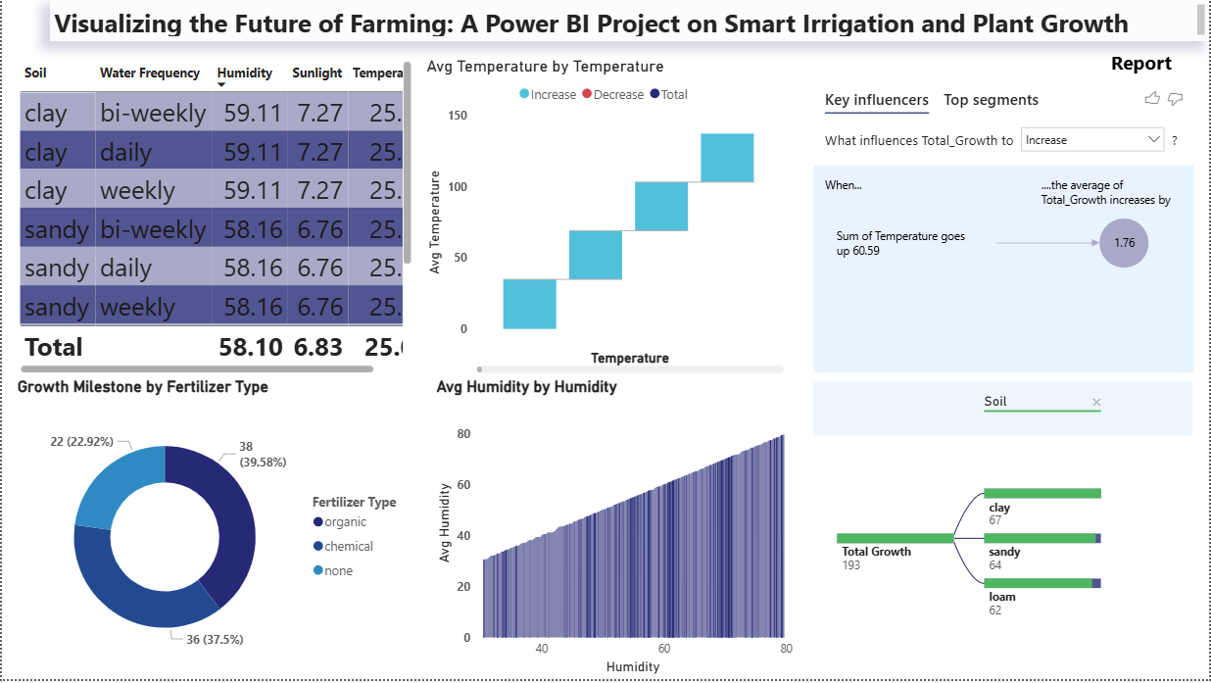

**Report**

|  |  |
| --- | --- |
| Date | 04-08-2025 |
| Team ID | Simran Gupta |
| Project Name | Visualizing the Future of Farming: |
| Maximum Marks | 5 Marks |

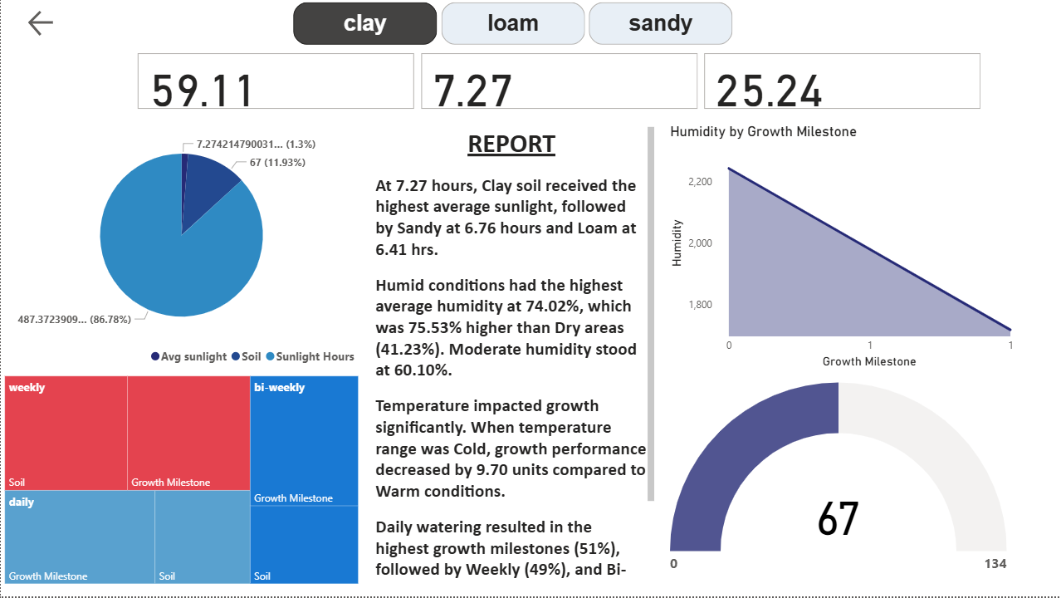

**The report provides an analysis of soil conditions and their impact on plant growth:**

1. Sunlight Exposure:
   1. Clay soil received the highest average sunlight at 7.27 hours
   2. Sandy soil followed with 6.76 hours
   3. Loam soil received 6.41 hours
2. Humidity Levels:
   1. Humid conditions had the highest average humidity at 74.02%
   2. This was 75.53% higher than dry areas (41.23%)
   3. Moderate humidity was recorded at 60.10%
3. Temperature Effects:
   1. Temperature signiﬁcantly impacted growth
   2. Cold temperature ranges decreased growth performance by 9.70 units compared to warm conditions
4. Watering Frequency and Growth:
   1. Daily watering resulted in the highest growth milestones (51%)
   2. Weekly watering followed at 49%
   3. Bi-weekly watering was also mentioned but percentage not speciﬁed
5. Additional Data:
   1. Current humidity: 58.16%
   2. Current sunlight: 6.76
   3. Current temperature: 25.08

The report highlights the importance of various environmental factors on plant growth, emphasizing the roles of soil type, sunlight exposure, humidity, temperature, and watering frequency.

# Conclusion / Observation

The “Future Grow Tech — Smart Farming” Power BI project successfully demonstrates the power of data visualization and analytics in modern agriculture. By analysing key parameters such as soil type, nutrient levels, and crop performance, the project provides farmers, agronomists, and stakeholders with a data- driven approach to enhance crop yield and optimize farming practices.

**Key Observations:**

* Soil Types (Clay, Loam, Sand) exhibit varying performance based on different nutrient levels and crop suitability.
* Through calculated KPIs and visualizations, users can easily identify which soil performs best for specific crop types.
* Utilization of filters, slicers, and calculated fields enhances user interactivity and provides a customized view of data.
* The dashboard empowers users with quick insights for making informed decisions, promoting sustainable agriculture.
* Performance testing validates that the report is optimized with efficient use of resources, ensuring smooth operation even with large datasets.

**Overall Impact:**

This project bridges the gap between technology and traditional farming, showcasing how Power BI can transform agricultural data into actionable insights. It serves as a scalable model for future implementations across various regions and crop types, contributing to the advancement of smart farming practices in India and beyond.

# Future Scope

The current project lays the foundation for data-driven decision-making in smart farming. However, to further enhance its capabilities and impact, several future developments can be envisioned:

1. **Integration with IoT Sensors**

Description: Real-time data from IoT devices (e.g., soil moisture sensors, weather stations) can be integrated directly into Power BI.

Benefit: Enables live monitoring and predictive insights for crop health and irrigation scheduling.

1. **Predictive Analytics with Machine Learning**

Description: Leverage Azure ML or Python/R scripts within Power BI to predict crop yields, pest risks, and soil degradation.

Benefit: Allows for proactive planning and early warning systems to improve farm productivity.

1. **Geo-Spatial Analysis**

Description: Incorporate geographical data visualization (using ArcGIS or map visuals in Power BI) to analyse regional performance.

Benefit: Helps in region-wise crop performance tracking and soil quality mapping.

1. **Mobile Dashboard Accessibility**

Description: Optimize dashboards for mobile devices through Power BI Mobile.

Benefit: Farmers and agronomists can access insights on the field, increasing convenience and actionability.

1. **Expansion to Other Crop Types and Regions**

Description: Extend the model to include a wider variety of crops and diverse soil zones. Benefit: Makes the solution scalable for different states and farming ecosystems.

1. **Multi-Language Support**

Description: Add support for regional languages within the Power BI reports. Benefit: Ensures inclusive access for non-English-speaking users across India.

**Appendix**

**Project Resources**

1. **Source Code & Data Files**
   * . The data preprocessing, DAX calculations, and Power Query transformations used in this project are available in the Power BI .pbix file.
   * . **File Name**: Future Grow Tech — Smart Farming.pbix
2. **GitHub Repository**
   * . All project resources, documentation, and version control are hosted on GitHub.
   * . GitHub Link
   * . <https://github.com/Simranefelibata/Future-Grow-Tech-smart-farming>
3. **Project Demo Video**
   * . A brief walkthrough of the dashboard with features explanation.

<https://drive.google.com/file/d/197_h_qzuYPbD_yQdwzTolEnXBun2SGsQ/view?usp=drive_link>

**Additional Resources**

* **Data Source**: [Kaggle, FAO USDA, Indian Gov-data.gov.in]
* **Tools Used**:
  + Microsoft Power BI
  + Microsoft Excel (for preprocessing)
  + Power Query Editor
  + DAX (Data Analysis Expressions)